SCHOOL OF COMPUTER SCIENCE AND ARTIFICIAL INTELLIGENCE |  |  |  |  | DEPARTMENT OF COMPUTER SCIENCE ENGINEERING
Program Name: B. Tech |  |  |  | Assignment Type: Lab |  |  | Academic Year:2025-2026
Course Coordinator Name |  |  |  | Venkataramana Veeramsetty
Instructor(s) Name
  Dr. V. Venkataramana (Co-ordinator)
  Dr. T. Sampath Kumar
  Dr. Pramoda Patro
  Dr. Brij Kishor Tiwari
  Dr.J.Ravichander
  Dr. Mohammand Ali Shaik
  Dr. Anirodh Kumar
  Mr. S.Naresh Kumar
  Dr. RAJESH VELPULA
  Mr. Kundhan Kumar
  Ms. Ch.Rajitha
  Mr. M Prakash
  Mr. B.Raju
  Intern 1 (Dharma teja)
  Intern 2 (Sai Prasad)
  Intern 3 (Sowmya)
  NS_2 ( Mounika)
Course Code |  |  | 24CS002PC215 | Course Title |  | AI Assisted Coding
Year/Sem |  |  | II/I | Regulation |  | R24
Date and Day  of Assignment |  |  | Week6 - Thursday | Time(s)
Duration |  |  | 2 Hours | Applicable to  Batches
AssignmentNumber:12.1(Present assignment number)/24(Total number of assignments)
 | Q.No. | Question |  |  |  |  |  | Expected Time  to complete
 | 1 | Lab 12: Algorithms with AI Assistance – Sorting, Searching, and Optimizing Algorithms  Lab Objectives:  - Apply AI-assisted programming to implement and optimize sorting and searching algorithms.  - Compare different algorithms in terms of efficiency and use cases.  - Understand how AI tools can suggest optimized code and complexity improvements.  Task 1: Implementing Bubble Sort with AI Comments  - Task: Write a Python implementation of Bubble Sort.  - Instructions:  - Students implement Bubble Sort normally.  - Ask AI to generate inline comments explaining key logic (like swapping, passes, and termination).  - Request AI to provide time complexity analysis.  - Expected Output:  - A Bubble Sort implementation with AI-generated explanatory comments and complexity analysis.  Prompt:  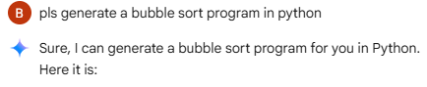  Code:  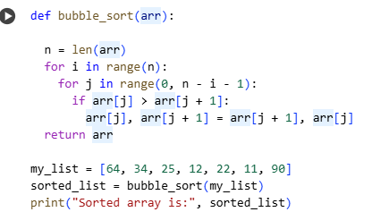  Output:  Prompt2:  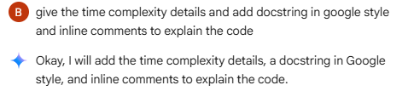  Code:  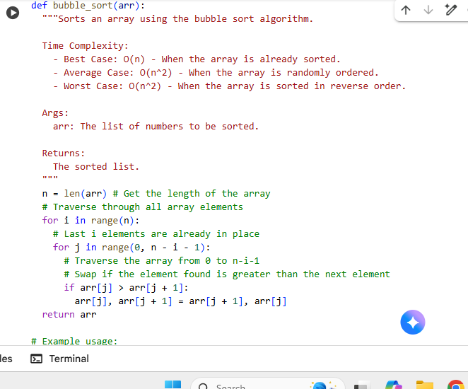  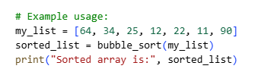  Output:  Task 2: Optimizing Bubble Sort → Insertion Sort  - Task: Provide Bubble Sort code to AI and ask it to suggest a more efficient algorithm for partially sorted arrays.  - Instructions:  - Students implement Bubble Sort first.  - Ask AI to suggest an alternative (Insertion Sort).  - Compare performance on nearly sorted input.  - Expected Output:  - Two codes (Bubble Sort + Insertion Sort).  - AI explanation of why Insertion Sort is more efficient for partially sorted data.  Prompt:  Code:  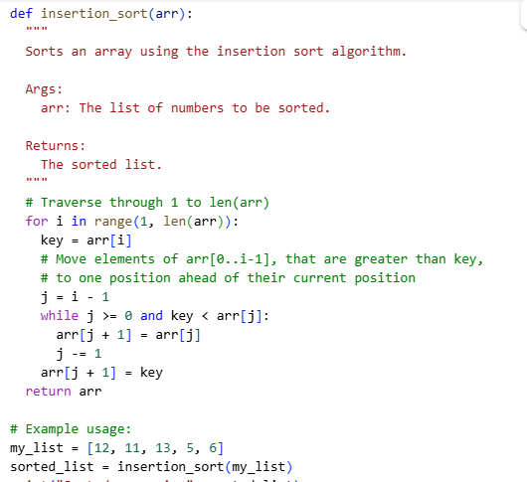  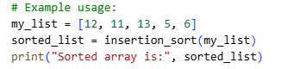  Output:  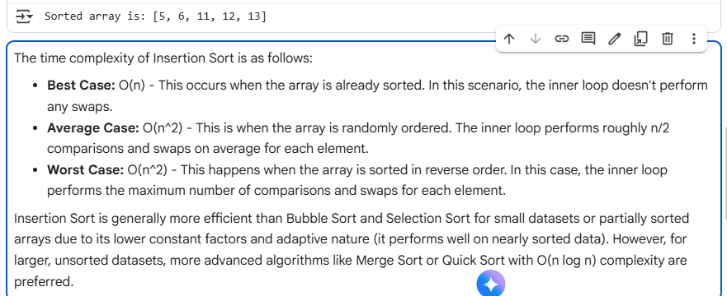  Prompt 2:  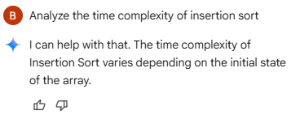  Output:  Task 3: Binary Search vs Linear Search  - Task: Implement both Linear Search and Binary Search.  - Instructions:  - Use AI to generate docstrings and performance notes.  - Test both algorithms on sorted and unsorted data.  - Ask AI to explain when Binary Search is preferable.  - Expected Output:  - Two implementations with docstrings.  - A student observation table comparing performance (Linear vs Binary Search). |  |  |  |  |  | Week6 - Thursday
Task 4: Quick Sort and Merge Sort Comparison
- Task: Implement Quick Sort and Merge Sort using recursion.
- Instructions:
  - Provide AI with partially completed functions for recursion.
  - Ask AI to complete the missing logic and add docstrings.
  - Compare both algorithms on random, sorted, and reverse-sorted lists.
- Expected Output:
  - Working Quick Sort and Merge Sort implementations.
  - AI-generated explanation of average, best, and worst-case complexities.
Prompt 1:
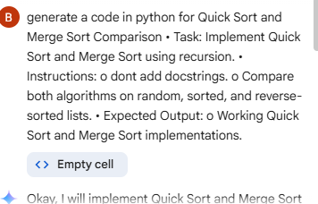
Code:
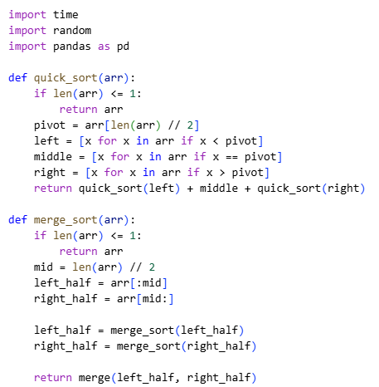
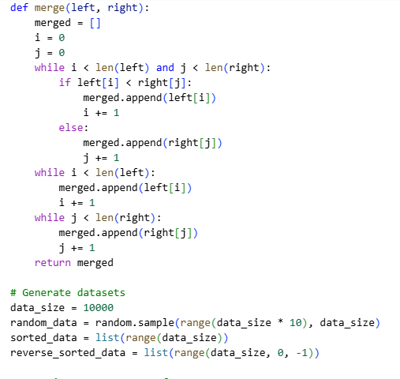
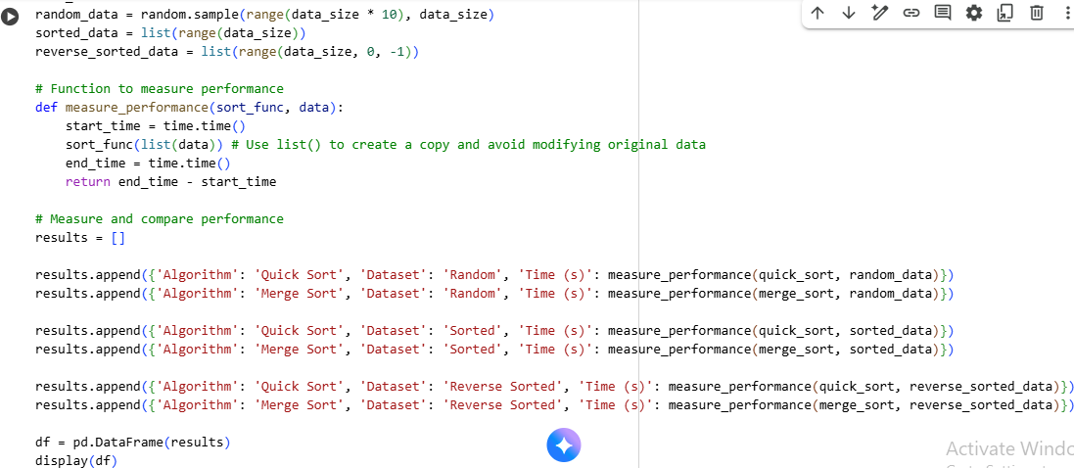
Output:
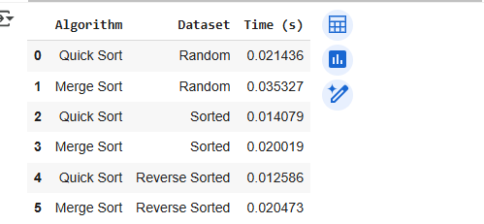
Prompt 2:
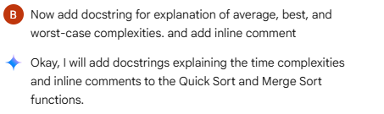
Code:
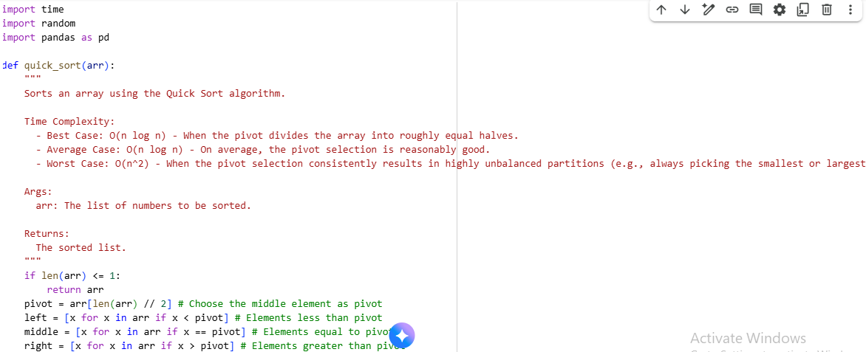
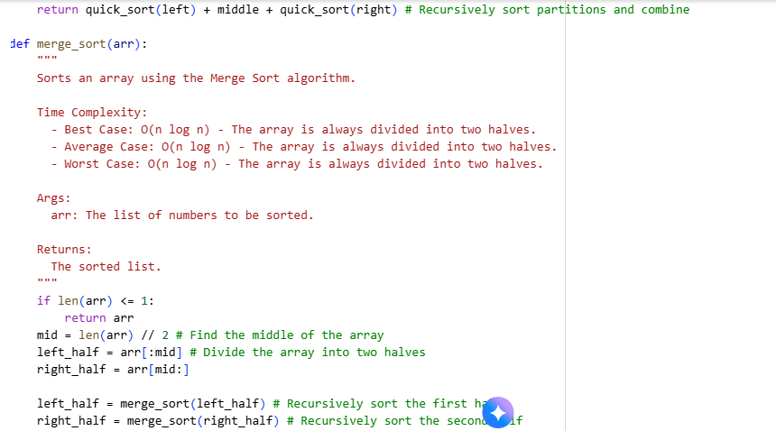
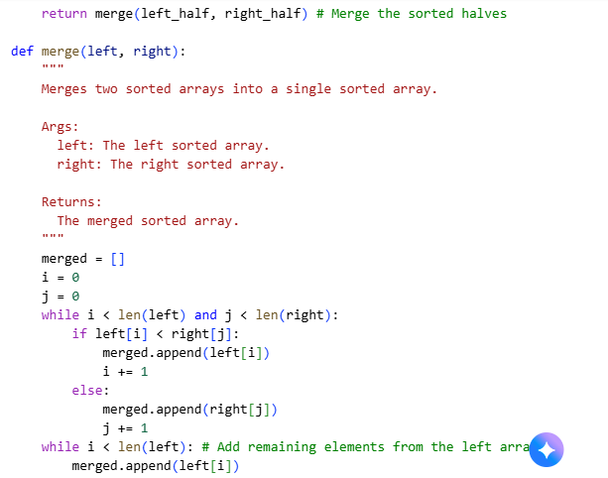

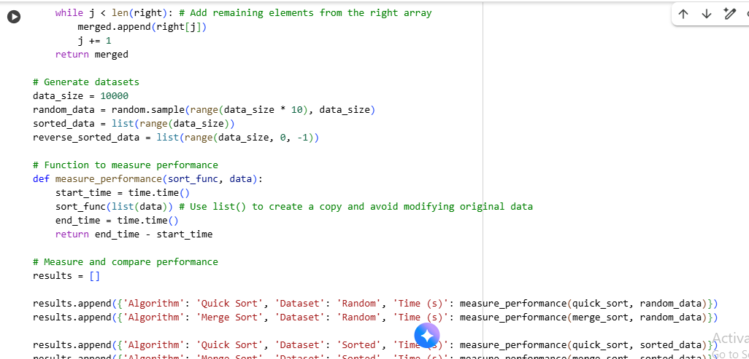
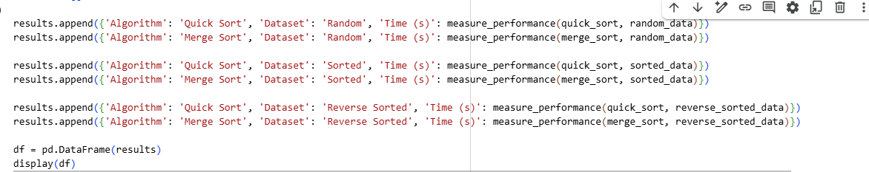
Output:
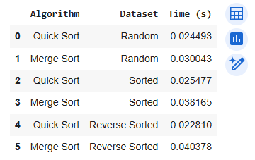
Task 5: AI-Suggested Algorithm Optimization
- Task: Give AI a naive algorithm (e.g., O(n²) duplicate search).
- Instructions:
  - Students write a brute force duplicate-finder.
  - Ask AI to optimize it (e.g., by using sets/dictionaries with O(n) time).
  - Compare execution times with large input sizes.
- Expected Output:
  - Two versions of the same algorithm (brute force + optimized).
  - AI explanation of how complexity was improved.

